LINDLE-AIR SPECS

|  |  |  |  |
| --- | --- | --- | --- |
| Roll NO. | NAME | SAP ID | BATCH |
| 18 | JATIN SINGH | 500067005 | BATCH-1 |
| 19 | KABIR GUPTA | 500066534 | BATCH-1 |
| 73 | YASH VERMA | 500067289 | BATCH-2 |
| 81 | VISHAL  DHIMAN | 500068607 | BATCH-2 |

GROUP NAME: ALPHA

Table of Contents

ABSTRACT 4

Entity Relationship Diagram(ERDs) 5

Data Flow Diagrams(DFDs) 6

PROBLEM STATEMENT 7

The 4 Manifesto of Agile Systems 8

INDRODUCTION 9

REVIEW 11

Objective of the Project 12

Outcome of the Project 13

Scrum Development Model 14

SOFTWARE CHARATERISTICS 15

Functionality 16

Reliability 17

Usability 18

Efficiency 19

Maintainability 20

Portability 21

Describing the four principles in our project 22

# ABSTRACT

Our Lindle project will work upon the idea of projection from lens at a particular surface. Implementing it with available hardware we already done so far, we need lens attached with a sort of specs, a system will display and give the instruction directly to the specs. System connected with the specs and then reflecting or splitting the light rays to the particular surface from the given lens or display.

Specs will provide the required information to the user on the desired surface or any type of medium. We will accomplish this project by making it user friendly. Security will be a part of this product that means without correct face recognition it is impossible to install this product on our face. After this process of Security purpose then there will be a quick initialization on which the system will instruct the given product attached to our face then LED illumination Polarised light shines forward to the surface. Software and hardware connection will be included on this document in later coming stages.

# Entity Relationship Diagram (ERDs)

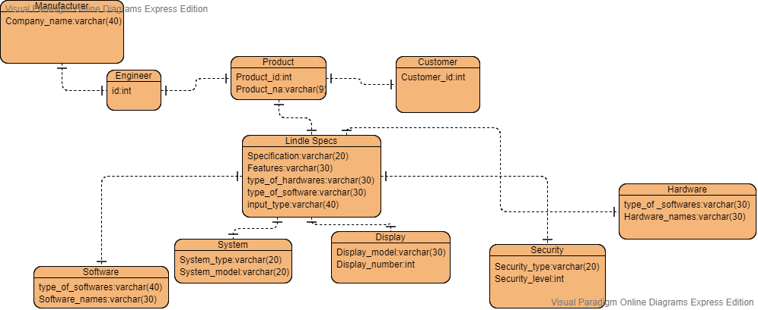

# Data Flow Diagrams (DFDs)

# Level 0:

# 

# Level 1:

# 

# PROBLEM STATEMENT

When kindle was launched, it emerged as a great success but still there are so many issues with its features. One of them is less reality touch, customers give feedbacks that they want feel of a book when flipping the pages and portability is also one of the issues with the product. To resolve this issue we created this project that promulgate more reality connection between customers and the users and the product is also more portable as it just has a glass like structure so it easy to carry while travelling and the surface is also a book which decrease the eye strain of the user. Our Lindle project will work upon the idea of projection from lens at a particular surface. Implementing it with available hardware we already done so far, we need lens attached with a sort of specs, a system will display and give the instruction directly to the specs.

# The 4 Manifesto of Agile Systems

The four main principles are kept in mind while making our project. These principles will build a foundational platform around our project. From the project point of view, we as a group built our Innovative project on Lindle-AIR Specs keeping in mind the 4 key principles.

The 4 Principles for Agile Systems are:

1. Individuals and Interactions over processes and tools.
2. Working Software over comprehensive documentation.
3. Customer Collaboration over contract negotiation.
4. Responding to Change over a following plan.

# INDRODUCTION

Our product will be beneficial to the end user in the long run. By engaging us in this project we will get an opportunity to enhance our skill set and to be efficient too. From the project perspective, the end user will be able to work on his reading skills and which will result in improving his vocabulary, soft skills. By incorporating the scrum development in our project will look complex but will look easier. Keeping the requirements of the end user in mind there will be constant interactions with the product designers and by exchanging ideas, it will result in a collaborative effort to make our product able to sell in the market, it will be efficient, functional, portable, easy to understand and maintain it. The product is open to change which in turn will open the doors of innovation, and therefore responding to change over the existing product. By keeping the end users in mind our product will have a certain reputation intact and will be able to sell globally in the market. Our innovative product augmented reality Lindle specs also known as (Lindle-AIR Specs), it will be associate with the latest technology and will be perfectly blend with the today advancement in technology.

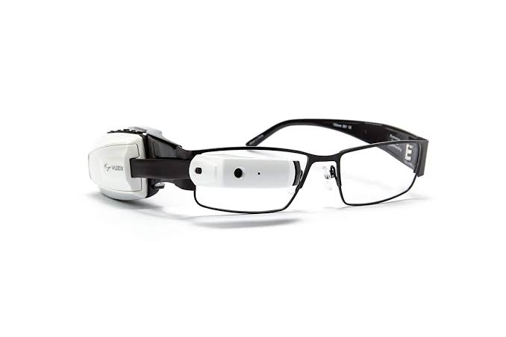

# REVIEW

Our Projects has undergone many changes while its processing as reflecting from the Introduction, we have also added a feature of face recognition in our project as security is a major concern nowadays. We tried to make our project budget friendly as we use normal projecting structure for creating our projects to make it more budget friendly for the end user. Using scrum method, we have involved the end user as much as possible, and tries to make it more personalized according to the user. If we talk about the risk of the project, we have tried to make it as less risky as we can by adding only required features in the project, but there can be risk in the budget reckoner.

We have tried to maintain the quality standards of our project as our projects will be compared to the already existing lens for which we have added more features in it to make it more secure and more user friendly. After this process of Security purpose then there will be a quick initialization on which the system will instruct the given product attached to our face then LED illumination polarized light shines forward to the surface.

# Objective of the Project

Detailed Information of the project:

This project consists of two physical hardware. One is light projecting spectacles that must have a storage chip of minimum size that can be fed into the spectacles easily. The light projecting spectacles is a miniature model of projector that throws light on a medium.

So, we as a group consisting of Kabir, Vishal, Jatin and Yash try to create a model of the above project. First of all, we will first study in detail about the projector and try to make it as small as it can be converted into the project needed projector.

So, the projector structure is explained by a diagram:

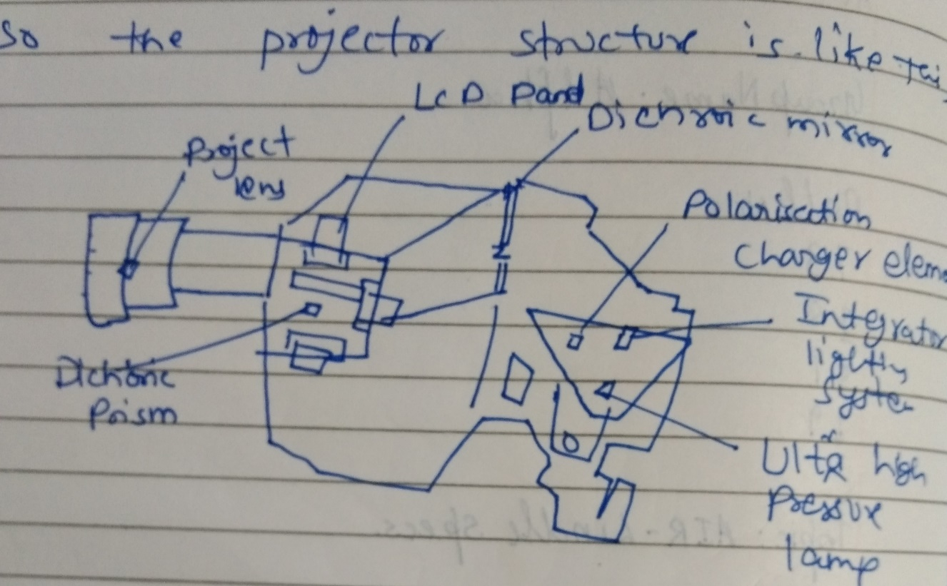We try to create a miniature model of the parts of the projector used in it. The one who is using these spectacles can be customised.

# Outcome of the Project

The outcome of this project is basically to make the end user life easier. This project deals with the information catcher that we can reflect our view or work capacity. The reliability will tell us about how efficiently this device or system will signify its features. The word easier means in the life of the end user is that it is making its life futuristic also reducing user effort.

## Scrum Development Model

This model is a strategic model where as a team reaches a software developer to reach a common goal as a team in order to make the product or software market ready.

This model is widely used and is a subset of the agile software development, this model has been observed in areas of complex work, Research technologies and advanced technologies.

This model can be understood better by a diagram:

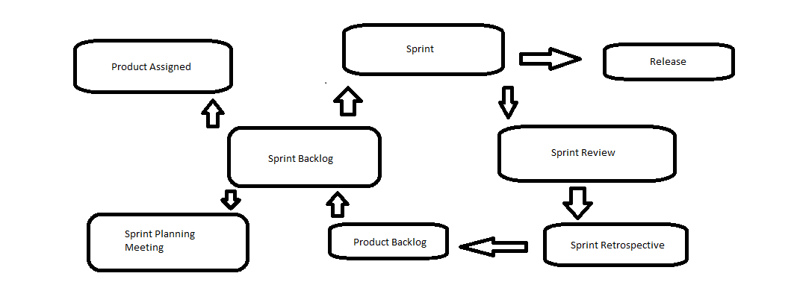

This model works on the principle of the agile framework. This can help in our project too.

In order to implement this in our project.

Scrum is mostly preferred for those development projects that are constantly altering or extremely developing requirements. This is used for prompt development of software that happens to include a series of iterations to generate required software.

We (alpha) used this methodology for project (lindle) as we need to develop lindle with fast pace and also there can be numeral changes during development. It is an ideal methodology because it brings back even the slowest project on track.

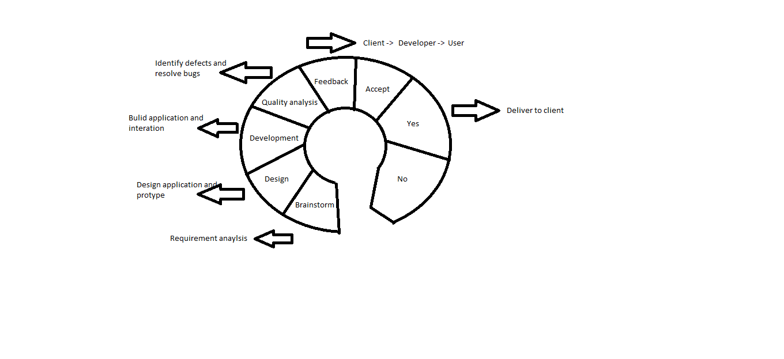

# SOFTWARE CHARATERISTICS

The software characteristics are very important on that basis it is implemented in our project that are very essential. Thinking about the project perspective the characteristics are the traits while developing the software or the project in order to meet the end user requirements.

The essential characteristics are described as below :

1. Functionality
2. Efficiency
3. Reliability
4. Usability
5. Maintainability
6. Portability.

These are the essential characteristics that we emphasize in the usage of our product to be successful in the future.

The flow – chart is seen below :

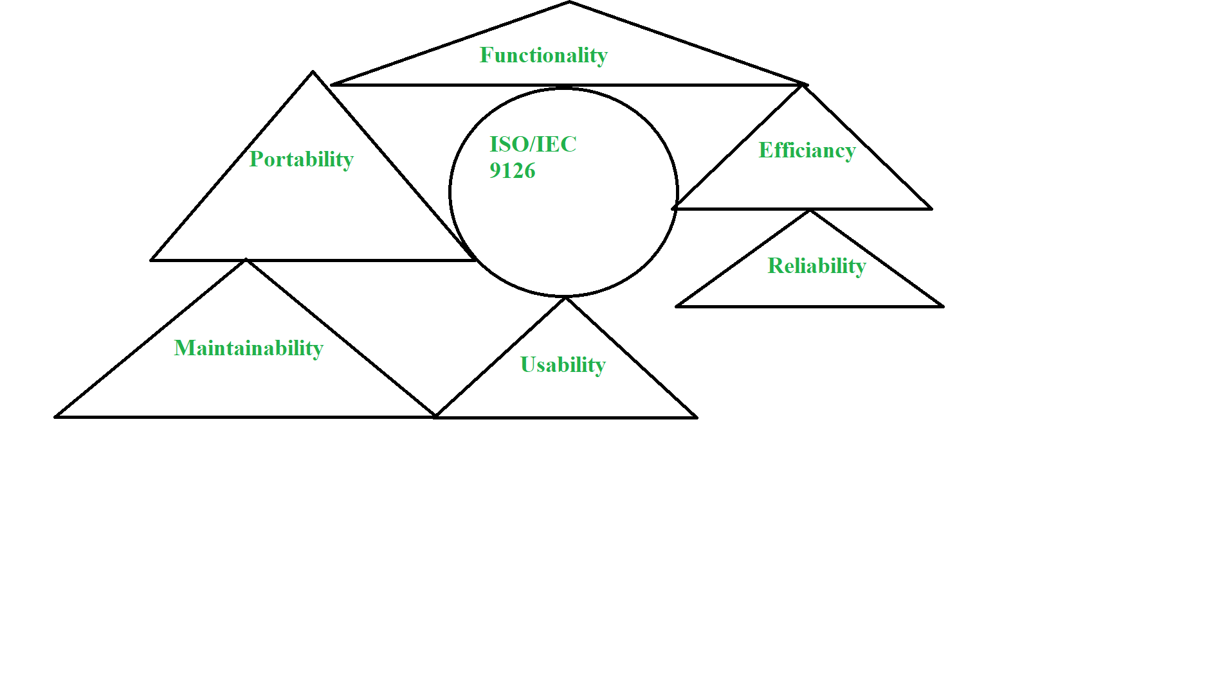

## Functionality

This is a branch of software characteristic that refers to the performance of a software that produce in a time frame. Means it refers to the degree of performance for an intended purpose. It performs the certain type of functions as seen below :

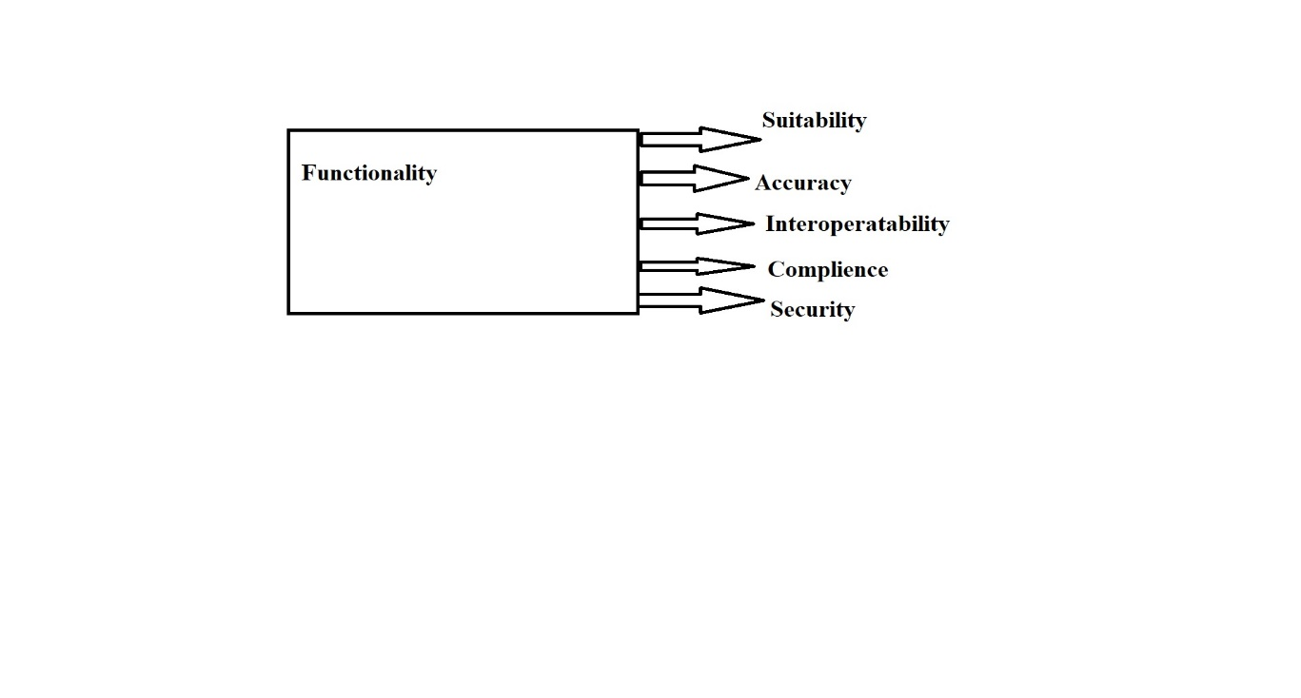

In our project the first under software characteristics is the Functionality. This is key feature and done accordingly. According to our project we want maximum output in a allotted time frame. Our project will adhere to the protocols and will be functional in the long run.

The functions are :

Suitability : The end user may like the product it should suitable for the user means that user can use functions to perform a specified task and user objectives.

Accuracy : The software or the product should be accurate in order to yield better results that means that it should provide the right atmosphere for the working product and effects should be good.

Interoperability : The software or the product should be capable of interacting with one or more systems.

Compliance : The software or the product should adhere to the protocols this is called compliance.

Security : the software or the product should be secured so that no unauthorised user can gain access into the systems. This the key feature our product should be secured by the unauthorised access.

## 

## Reliability

This is also a software characteristic where the product that the end user is using should maintain it performance capability and able to stand under a certain time frame. That is when we say that the software is reliable to use. It performs some functions they are as follows :

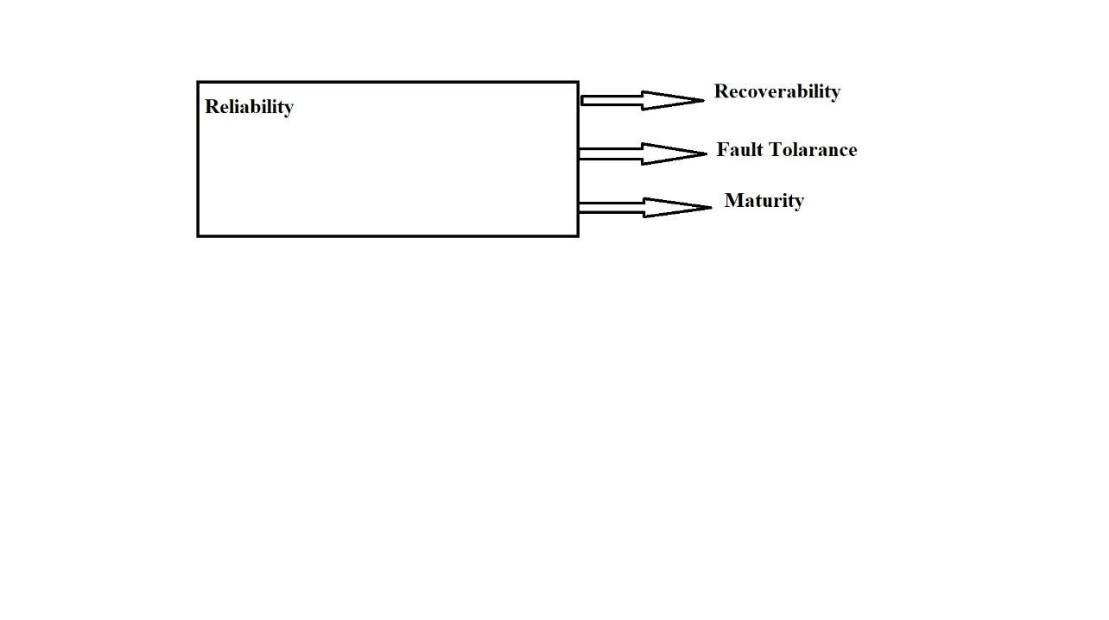

In our project the second under software characteristic is Reliability. Our product will try to maintain the level of performance and able to stand under the certain condition and able to deliver the output in a allotted time frame, the functions are as follows:

Recoverability: Our product will be able to recover from a situation like if our product has failed or crashed it will be able to recover and maintain its performance in a scenario. This is very important feature as our product will able to try to incorporate this.

Fault Tolerance: Our product will able to handle the fault tolerance in case the failure is observed in our system or a product it will try to maintain the level of performance and able to retrieve data in case mishaps occurs.

Maturity: Our product will be try to avoid failure and here the maturity plays a vital role in our project.

## Usability

This is a software characteristic where the software or the product can be used by the end user with ease the amount of effort or time will be reduced this will result in faster understanding of the product. Usability performs certain functions as follows:

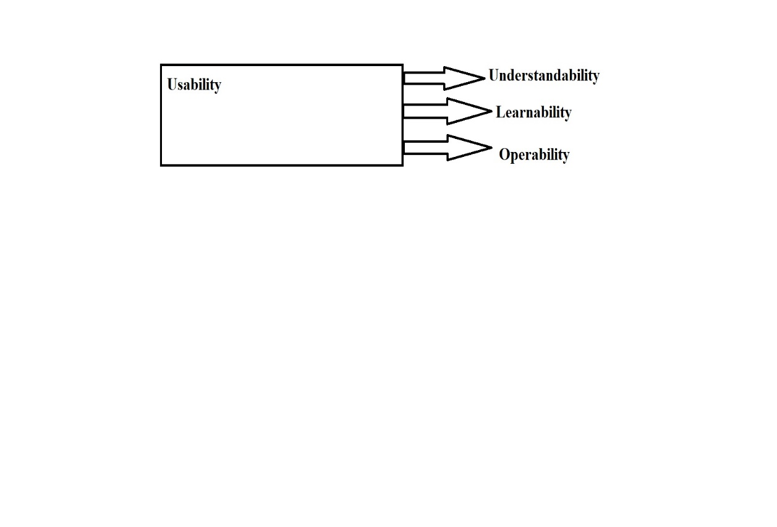

In our project the third under software characteristic is Usability, this is an important feature of the software characteristic so that user can understand the product in a faster manner. There are some certain functions that are there as follows :

Understandability: Our product will be easy to understand that how the product will be used it will also be suitable for the user to use this will result in where the user can read certain facts with just a press of a button. In this case if the user wants to read a book it can directly gather data without a tangible book in hand or by an artificial intelligence voice can read the book just by the retention of the data.

Learnability: Our product will be much easier to learn and how the product will actually work in person it will showcase the practical aspect in a given scenario. This would enable the users to learn it faster.

Operability: Our product will be easy to operate and is user-friendly at the same time with this product they can use in their daily routine or at work or on a vacation as well.

## Efficiency

This is a software characteristic where the software or a product will try to utilize minimum memory space and will be able to execute the tasks much faster. Our project will be able to do that. There certain functions that is needed to keep in mind to design such a product :

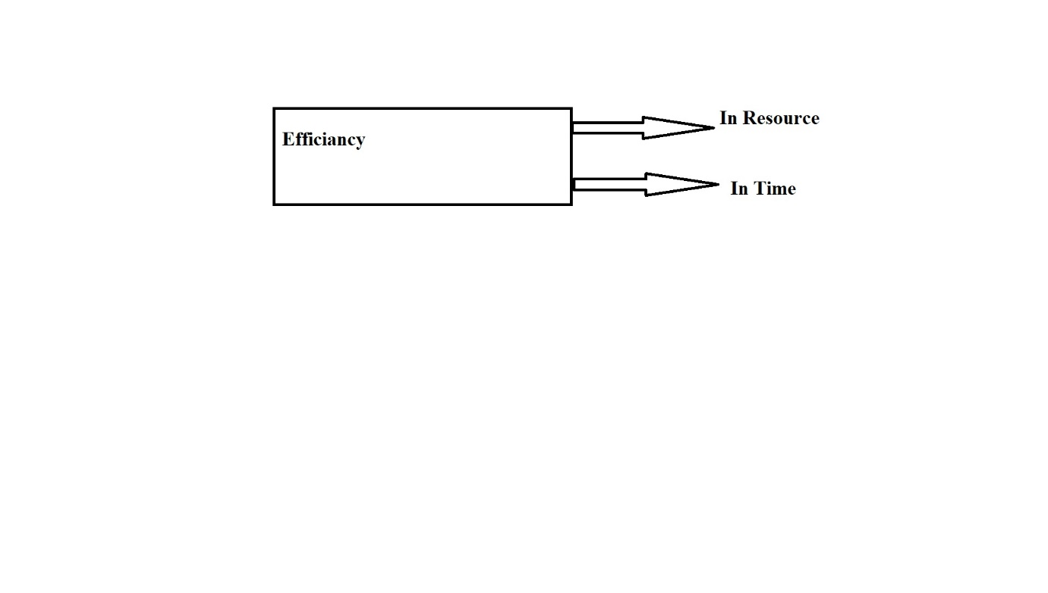

In our project the fourth under software characteristic is the Efficiency, as mentioned earlier our product will be efficient to handle and to use by the end user.

In Resource: Our product will be able to use required resources in an appropriate time frame when our product needs to perform a specified action under an allotted time frame.

In Time: Our product will able to deliver response time and the throughput will be faster under a minimum time frame.

## Maintainability

This is a software characteristic by which we can modify or upgrade the software and improve its performance and correct the errors. The software able to maintain and will get new features as well. It performs some functions :

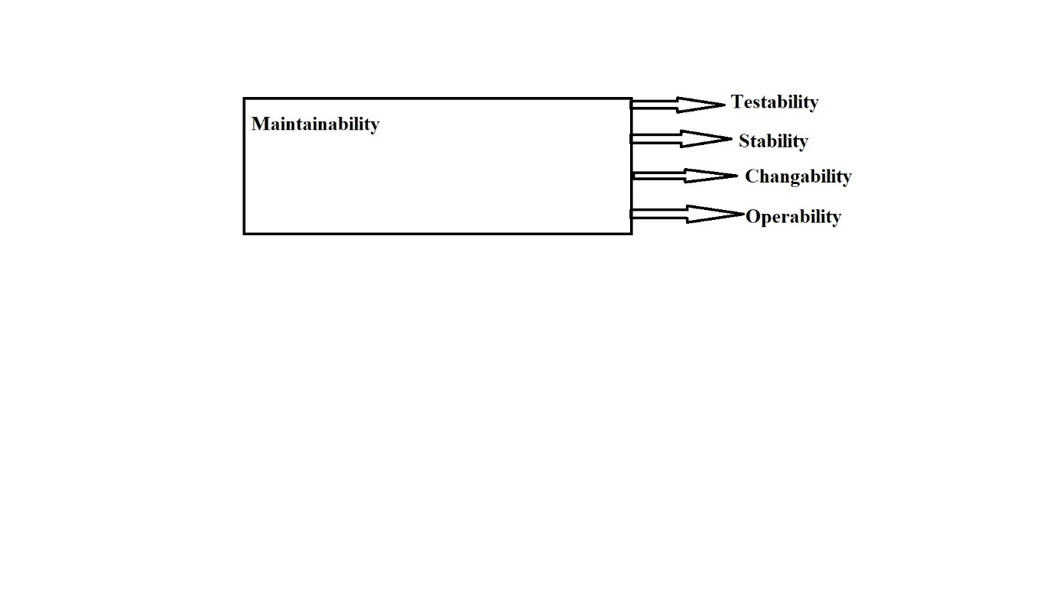

In our project the fifth one under software characteristic is Maintainability, our project will give an upgrade to the product where ever necessary and will deliver what the end user wants and will be at the optimum level. The functions are as follows :

Testability : Our product will be fully tested and approved but in case of a failure it will try to maintain its performance and backup will also be there if the data is lost.

Stability : Our product will be a stable product so a that it does not send any unwanted upgrades and it will be secured as well.

Changeability : Our product will be easily changeable and it will enable a specified modification to be implemented to the intended part.

Operability : Our product will have high value of operable and by that user can perform the tasks much faster and in a limited time frame. The product will have high level of system software running and application as well.

## 

## Portability

This is a software characteristic where the software is transferred from one environment to another with minimum changes. The functions are as follows :

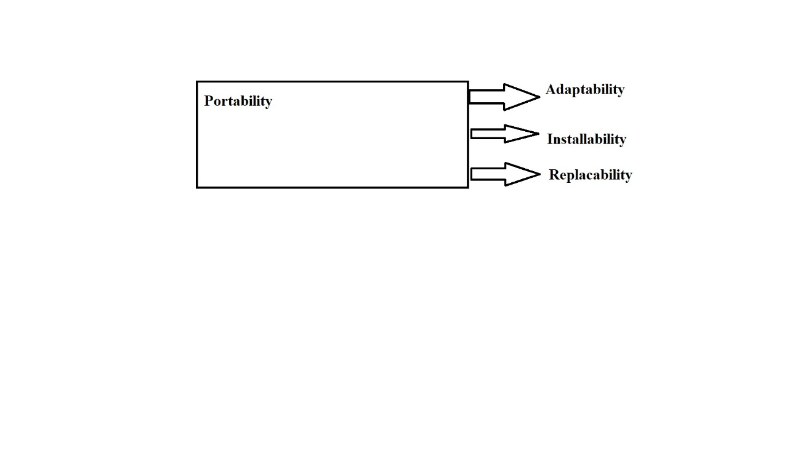

In our project the last one in the software characteristic is the Portability, our product will be good to use and will be portable as well and perform the tasks much faster even when transferred from one environment to another. The functions are discussed :

Adaptability: Our product will be able to adaptable for the different environments as well and able to meet the requirements specified.

Install ability: Our product will be installable in any specified environment as well.

Replaceability: Our product can replace other products that depends from product and the way of functioning.

## 

## Describing the four principles in our project

1. Individuals and Interactions over processes and tools.

So, our Lindle Project is totally based upon the human interaction, Making it

comfortable will be our first priority. Processes we are going to use in our project like

applying methodologies and principles etc , beyond these further implementations we

will see individual cooperation regarding the product that whether they are going to

cooperate with our product or not. Tools like Camera and Display will be set

according to the user compatibility by measuring our compatibility in behalf our

future user.

2. Working Software over comprehensive documentation

Software we are going to use in our project are Facial Recognition, Photo

Manipulation and Projector Controller Software. The principle clearly gives us an understanding that well-known full working software is important then project

documentation that is we have to test it before providing final approach. Tests include

that the projector is splitting light properly or not and Facial Recognition software

is providing security or not.

3. Customer collaboration over contract negotiations

Customer should be fully independent with our product though collaboration with one

or more product development parties because of the proper deal it is mandatory for

our product to deliver before signing any type of negotiations. Our Lindle specs might

we have some limitation as the functions desired by the user so the user can freely

collaborate with some other parties.

4. Responding to change over following a plan

If our product ever need modification like Security, Software, Hardware and various

features like projection, Recognition etc then we will see the responding change over following strategies to accomplice our project. Some of the methodologies lacks

backtracking process so we need first to collaborate what will be our next step then

according to that step we will going to react upon conditions. First required

modifications then strategies.